|  |  |
| --- | --- |
| Team ID | PNT2022TMID13904 |
| Project Name | CONTAINMENT ZONE ALERTING APPLICATION |

IBMDB2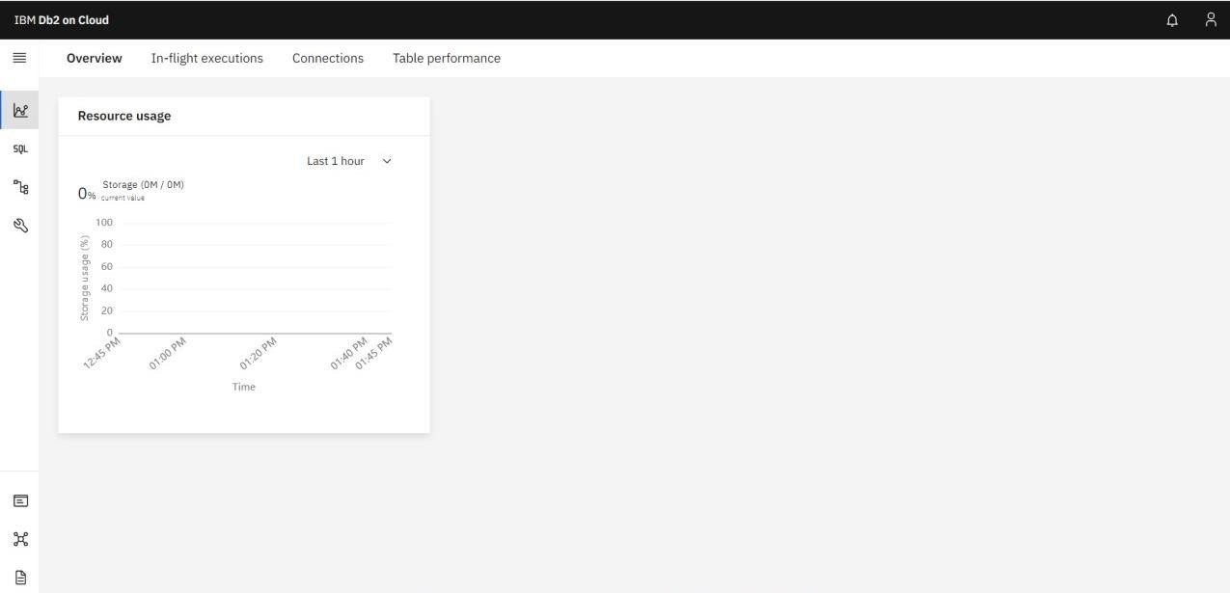:Implementing Web Application



